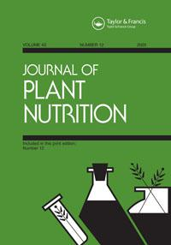**Journal of Plant Nutrition**

**ISSN: 0190-4167 (Print) 1532-4087 (Online) Journal homepage:** [**https://www.tandfonline.com/loi/lpla20**](https://www.tandfonline.com/loi/lpla20)



**Cobalt and molybdenum stimulate compounds of primary metabolism, nitrogen forms, and photosynthetic pigments in peanut plants (*Arachis* *hypogaea* L.)**

**Thais Grassi Gericó, Renan Francisco Rimoldi Tavanti, Jéssica Pacheco de Lima, Rodolfo Pires Ribeiro, Leandro Cesar Cusim dos Santos, Marcio Souza da Silva & André Rodrigues dos Reis**

**To cite this article:** Thais Grassi Gericó, Renan Francisco Rimoldi Tavanti, Jéssica Pacheco deLima, Rodolfo Pires Ribeiro, Leandro Cesar Cusim dos Santos, Marcio Souza da Silva & André Rodrigues dos Reis (2020) Cobalt and molybdenum stimulate compounds of primary metabolism, nitrogen forms, and photosynthetic pigments in peanut plants (*Arachis hypogaea* L.), Journal ofPlant Nutrition, 43:12, 1907-1922, DOI: [10.1080/01904167.2020.1750646](https://www.tandfonline.com/action/showCitFormats?doi=10.1080/01904167.2020.1750646)

**To link to this article:** <https://doi.org/10.1080/01904167.2020.1750646>



[View supplementary material](https://www.tandfonline.com/doi/suppl/10.1080/01904167.2020.1750646) 



[Submit your article to this journal](https://www.tandfonline.com/action/authorSubmission?journalCode=lpla20&show=instructions) 



[View related articles](https://www.tandfonline.com/doi/mlt/10.1080/01904167.2020.1750646) 



Published online: 13 Apr 2020.



Article views: 239



[View Crossmark data](http://crossmark.crossref.org/dialog/?doi=10.1080/01904167.2020.1750646&domain=pdf&date_stamp=2020-04-13)



Full Terms & Conditions of access and use can be found at

<https://www.tandfonline.com/action/journalInformation?journalCode=lpla20>

JOURNAL OF PLANT NUTRITION



2020, VOL. 43, NO. 12, 1907–1922

<https://doi.org/10.1080/01904167.2020.1750646>



Cobalt and molybdenum stimulate compounds of primary

metabolism, nitrogen forms, and photosynthetic pigments in peanut plants (Arachis hypogaea L.)

Thais Grassi Gericoa, Renan Francisco Rimoldi Tavantib, Jessica Pacheco de Limac, Rodolfo Pires Ribeirod, Leandro Cesar Cusim dos Santose, Marcio Souza da Silvab, and Andre Rodrigues dos Reisa,b

aS~ao Paulo State University (UNESP), Tup~a, SP, Brazil; bS~ao Paulo State University (UNESP), Ilha Solteira, SP, Brazil; cS~ao Paulo State University (UNESP), Jaboticabal/SP, Jaboticabal, SP, Brazil; dBeatrice Comercio Importac¸~ao Exportac¸~ao Amendoim Ltda, Tup~a, SP, Brazil; eEl Carmen Sementes do Brasil. Av Tamoios, Brazil Centro, Tup~a, SP

ABSTRACT

The objective of this study was to evaluate the effects of cobalt (Co) and molybdenum (Mo) doses in the treatment of seeds on the biosynthesis of nitrogen compounds, photosynthetic pigments, sugars, and production of peanut plants. The doses of Co and Mo used were 0, 2, 3, and 4 mL kg 1 seed, which were applied immediately before sowing. Seeds treated with Co and Mo at a dose of 4 mL kg 1 yielded peanut plants with higher con-centrations of photosynthetic pigments, carotenoids, and sucrose in leaves. Application of Co and Mo doses also increased biological nitrogen fixation by increasing the concentration of allantoic acid, nitrate, ammonia, and amino acids in leaves. The concentration of total amino acids corre-sponded to most of the nitrogen compounds (on average 50%), followed by the concentrations of nitrate (35%), ammonia (11%), allantoic acid (7%), and allantoin (0.2%). Application of 4 mL kg 1 increased the production of total amino acids compared with the control treatment. Pod yield was not affected by the Co and Mo doses; however, treatment of peanut seeds with 4 mL kg 1 was the most viable alternative for increased production of primary metabolism compounds, nitrogen forms, and photosynthetic pig-ments in peanut plants. This study provides important information regard-ing the role of Co and Mo in the biological nitrogen fixation of peanut plants. Future experiments should be conducted using a dose of 4 mL kg 1 with different genotypes to verify the potential for increasing peanut yield.

ARTICLE HISTORY

Received 2 September 2019 Accepted 23 March 2020

KEYWORDS

amino acids; mineral nutrition of plants; nitrogen compounds; treatment of seeds; ureides

Introduction

Peanut (Arachis hypogaea L.), one of the main oilseed plants grown worldwide, is an excellent source of lipids and proteins, and it is used in the food industry to produce cooking oil and snacks (Pawar et al. 2018). Worldwide peanut production in 2016 was approximately 43.9 million tons. China leads the world market as the main producer, with 37.8% of the total volume produced. In exporting countries such as Brazil, peanuts are also grown in succession cropping

CONTACT Andre Rodrigues dos Reis  andre.reis@unesp.br  S~ao Paulo State University (UNESP), Tup~a, SP 17602-496, Brazil.

 Supplemental data for this article can be accessed at <https://doi.org/10.1080/01904167.2020.1750646>.

2020 Taylor & Francis Group, LLC

1908  T. G. GERICÓ ET AL.

systems, especially after sugarcane (Saccharum spp.) crops, as a strategy for the amortization of production costs, sugarcane field renovation, soil acidity correction, and fertilization. The crop also demonstrates excellent agricultural suitability for green fertilization because it is not demand-ing in terms of mineral fertilizer inputs and chemical pesticides (Gerico et al. 2019).

Peanut depends on biological nitrogen fixation for its nitrogen nutrition, and nitrogen fertiliza-tion is not used for this crop (Caires and Rosolem 2000). In acidic soils with low calcium levels, low availability of molybdenum (Mo), and toxic levels of manganese, the absorption of nitrogen by peanuts is impaired and directly affects the yield (Rosolem and Caires 1998). In contrast, the greater efficiency of biological nitrogen fixation has been associated with the application of lime (Gashti, Vishekaei, and Hosseinzadeh 2012), cobalt (Co) (Gad 2012), and Mo (Quaggio et al. 2004).

In biological nitrogen fixation, Co is associated with a nucleotide of vitamin B12, also known as cobalamin, cobamide, or cyanocobalamin (El-Sheekh et al. 1992; Gad 2012). This vitamin func-tions as a coenzyme that is necessary for the biosynthesis of leghemoglobin, an oxygen carrier, and hemeprotein, which buffers the oxygen-free concentration in the nodule cell cytoplasm, thus increasing the efficiency of the nitrogenase enzyme to break the double-bond of atmospheric nitrogen (Ali et al. 2010).

Mo is a cofactor of the enzymes nitrogenase and nitrate reductase, which are essential for nitrogen fixation and assimilation by plants (Hille, Nishino, and Bittner 2011). These enzymes transform ammonium and nitrate (Schwarz and Mendel 2006). Nitrite is reduced to ammonium by nitrite reductase, Ammonium is incorporated into amino acids via glutamine synthetase and glutamate synthase pathways (Lea and Miflin 2011).

Mo is a cofactor of the enzymes nitrogenase and nitrate reductase, which are essential for the processes of nitrogen fixation and assimilation by plants (Hille, Nishino, and Bittner 2011). These enzymes operate in nitrogen transformation into ammonium and nitrate reduction into nitrite (Schwarz and Mendel 2006). During the process, nitrite is also reduced to ammonium by the enzyme nitrite reductase, an inorganic form in which nitrogen is incorporated into organic com-pounds via the glutamine synthetase and glutamate synthase pathways (Lea and Miflin 2011).

Several studies have attempted to increase the efficiency of biological nitrogen fixation in plants (Fukami, Cerezini, and Hungria 2018). However, the main focus has been directed toward the exploration of microorganisms that are more efficient for nitrogen fixation in legumes such as soybean (Moretti et al. 2018). Regarding an adequate nutritional supply of Co and Mo (CoMo) and the associated effects on plant primary metabolism, little information has been acquired under field conditions. It has been suggested that an adequate supply of CoMo for crops such as peanuts is complementary to microorganism exploration, as this crop is symbiotically active with several species that are native to the soil (Yoshida 1998; Castro et al. 1999).

In addition to contributing to the biological nitrogen fixation process, Co has a direct effect on photosystem II (PSII) in plants (Tripathy, Bhatia, and Mohanty 1981; Tripathy, Bhatia, and Mohanty 1983; El-Sheekh and Hammouda 1992), with changes in the distribution of excitation energy in favor of photosystem I (PSI). These phenomena also support an increase in the forma-tion of adenosine triphosphate (ATP) caused by the cyclic flow of electrons in cell chloroplasts. This behavior is also assumed to be associated with increases in the concentrations of soluble sug-ars in plant tissues.

Czerpak et al. (1994) reported that concentrations between 5 10 6 and 5 10 5 mol L 1 of Co in freshwater green algae cells (Chlorella pyrenoidosa) exerted a stimulatory effect due to the increase in fresh weight, dry weight, levels of chlorophylls a and b, total carotenoids, water-sol-uble proteins, and sugars compared with the control treatment without Co. In addition, seed treatment and leaf application of Co in peanut plants increased the size and concentration of leghemoglobin in nodules (Shiv Raj 1987).

JOURNAL OF PLANT NUTRITION  1909

In addition to nitrate reductase and nitrogenase, enzymes containing Mo have been identified in Arabidopsis (Arabidopsis thaliana), tomato (Solanum lycopersicon), and wheat (Triticum aesti-vum) plants (Hesberg et al. 2004; Yesbergenova et al. 2005; Montalbini 1998), i.e., xanthine dehydrogenase/oxidase, involved in the catabolism of purines and biosynthesis of ureides in legu-minous plants (Werner and Witte 2011); aldehyde oxidase, involved in the synthesis of abscisic acid (Nishiyama et al. 2011); and sulfite oxidase, which can convert sulfite to sulfate (Brychkova et al. 2013). These discoveries represent important steps detailing the role of Mo in the catabol-ism of sulfur-containing amino acids such as cysteine and methionine (Mendel and H€ansch 2002; Williams and da Silva 2002).

The hypothesis was that an adequate supply of CoMo in peanut plants increases biological nitrogen fixation efficiency and improves primary metabolism in plants. This study aimed to evaluate the effects of CoMo application to peanut seeds on photosynthetic pigments, sugars, and nitrogen compounds in peanut plants and their relationships with peanut plant yield.

Materials and methods

Description of the study site and experimental configuration

The study was conducted in the agricultural year 2017/2018 in an area located in the municipality of Tup~a, S~ao Paulo state, Brazil (21 5600500 S; 50 3004900 W; 524 m). According to the Koppen€

climate classification, the climate of this region is considered “Cfa”, a tropical climate with two distinct seasons – a rainy season during the summer and a dry season during the winter. The mean annual temperature and rainfall are 20.9 C and 1269 mm, respectively (Figure 1).

The soil in the area was classified as a sandy clay Dystrophic Red Latosol (LVd) according to Brazilian Soil Classification System (Embrapa 2018), an Oxisol according to Soil Survey Staff (2014), with clay content in 0.00–0.20 m layer of 400 g kg 1, silt 83 g kg 1 and sand 517 g kg 1, determined by pipette method (Embrapa 2017). The mean soil chemical characteristics in the evaluation period are presented in Table 1. The element determination methods followed the standards of Van Raij et al. (1996).

Preparation of the area was initiated 10 days before the start of the experiment with the application of dolomitic limestone (TNP ¼ 90%; total neutralizing power of limestone in relation to CaCO3) at a dose of 448 kg ha 1 according to the calculated needs for increasing the base saturation by 70% (Figure 1). Subsequently, the lime was incorporated with a heavy disk plow and a light disk plow for terrain leveling. At the time of peanut sowing, corrective phosphorus was applied in a total area using 80 kg ha 1 of P2O5 (simple superphosphate source), which was incorporated with a light disk plow at a depth of 0.00–0.10 m, as recommended by Ribeiro et al. (1999).

The peanut cultivar Granoleico was used, a variety of the Virginia runner group, a long cycle, creeping plant with a maturity of 130 days. The seeds were treated with a product based on carbendazim (15%) and thiram (35%) at a dose of 150 g kg 1 for the prevention of diseases at the onset of the crop cycle. Sowing was performed manually in the experimental plot containing four 4-m rows 0.90 m apart, result-ing in a usable area of 3.6 m2 and a plant population density of 311.000 plants ha 1.

A randomized block experimental design was used with four replicates, with four doses of a product based on Co (13.6 g L 1) and Mo (136 g L 1) as a factor: 0, 2, 3, and 4 mL kg 1. The treatments were applied to the dried seeds after pesticide application. The crop management prac-tices followed the technical recommendations for cultivation and were performed homogeneously throughout the experimental station. During the full blooming period of the peanut crop, fully developed leaves (4th leaf of the main stem from the base) were collected, and the concentrations of photosynthetic pigments, primary metabolites (sucrose and total sugars), nitrogen compounds (allantoin, allantoic acid, and total ureides), nitrate, ammonia, and amino acids were analyzed.

1910  T. G. GERICÓ ET AL.

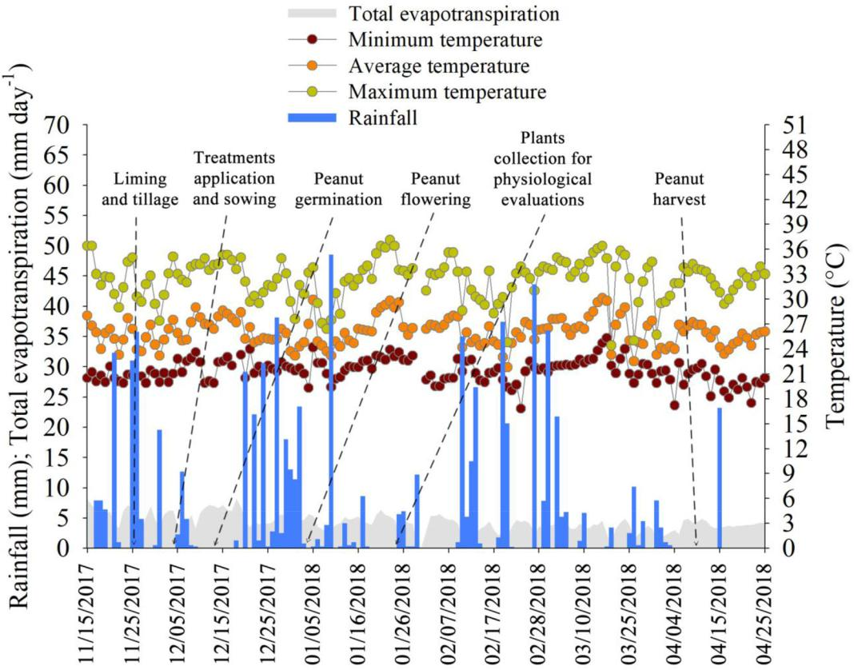

Figure 1. Rainfall (mm), relative air humidity (%), and minimum, mean, and maximum temperature ( C) during the experiment in the municipality of Tup~a, S~ao Paulo, Brazil.

Table 1. Soil chemical and physical characterization of the experimental area.

|  |  |  |  |  |  |  |  |  |  |  |  |  |  |  |  |  |  |  |
| --- | --- | --- | --- | --- | --- | --- | --- | --- | --- | --- | --- | --- | --- | --- | --- | --- | --- | --- |
| Soil layer | pH | SOM | 1 | P | S | 1 | K | Ca | Mg | H | 1þ Al | CEC | BS | B | Cu | Fe | 1 Mn | Zn |
|  | – | g kg |  | mg kg | |  |  |  | mmolc kg | |  |  | % |  |  | mg kg |  |  |
| 0.00–0.20 m | 5.2 | 60.0 |  | 9.0 | 3.0 | | 1.7 | 11.0 | 6.0 | 11.0 | | 29.7 | 63.0 | 0.1 | 0.4 | 25.0 | 11.5 | 0.9 |

pH: determined in CaCl2 solution; SOM: soil organic matter content determined by potassium dichromate oxidation method; P, K, Ca and Mg: determined by resin method; H þ Al: potential acidity determined by Shoemaker-McLean-Pratt (SMP) buffer method; CEC: cation exchange capacity; BS: base saturation; B determined by hot water method; Cu, Fe, Mn and Zn deter-mined by diethylene triamine penta-acetic acid – DTPA.

Photosynthetic pigments

Chlorophyll a, chlorophyll b, total chlorophyll, carotenoids, pheophytin a, pheophytin b, and total pheophytin levels were quantified using the spectrophotometric method proposed by Lichtenthaler (1987), using fresh plant material stored in 80% acetone extract.

Total sugars and sucrose

To analyze sucrose and total sugars, the material was extracted according to the method described by Bieleski and Turner (1966). For the extraction, 1 g of fresh plant material (leaves) was macer-ated using a porcelain mortar and pestle and weighed, followed by the addition of 10 mL of MCW solution (60% methanol, 25% chloroform, and 15% water) in a 15-mL Falcon tube. The material was homogenized by vortexing and then centrifuged in a refrigerated centrifuge at

|  |  |
| --- | --- |
| JOURNAL OF PLANT NUTRITION | 1911 |



10,000 rpm for 10 minutes at 4 C. To another tube was added 4 mL of MCW extract supernatant, 1 mL of chloroform, and 1.5 mL of water. After phase separation, the concentration of total sugars and sucrose in the water-soluble phase was determined.

To quantify total sugars (DuBois et al. 1956), 20 mL of plant extract, 500 mL of 5% phenol, and 2 mL of concentrated sulfuric acid were added to a glass tube. The mixture was homogenized by vortexing, and after cooling to room temperature, the absorbance at 490 nm was read using a spectrophotometer. The results are expressed as mg g 1 FW (fresh weight).

To quantify sucrose (Van Handel 1967), 50 mL of extract, 500 mL of 30% KOH, and 2 mL of concentrated H2SO4 were added to a glass tube. The mixture was homogenized by vortexing and oven-dried at 100 C for 10 minutes. After cooling to room temperature, the absorbance at 490 nm was read using a spectrophotometer. Both quantifications were performed using a stand-ard sucrose curve. The results for sucrose are expressed as mg g 1 FW.

Ureides

For the determination of total ureides (allantoin þ allantoic acid) in peanut leaves, the method of Vogels and Van der Drift (1970) was used. The assay consists of two phases. In Phase 1, 250 lL of MCW extract supernatant, 250 lL of 0.5 M NaOH, and 1 drop of phenylhydrazine were heated in an oven at 100 C for 8 minutes and then cooled to room temperature. In this phase (alkaline hydrolysis), allantoin is hydrolyzed to allantoic acid. In Phase 2, 250 lL of 0.65 N HCl was added and heated again at 100 C for 4 minutes (acid hydrolysis); this is when the hydrolysis of allantoic acid to glyoxylate occurs. The assay was cooled to room temperature, and then 250 lL of 0.4 M phosphate buffer pH 7.0 and 250 lL 0.33% phenylhydrazine solution were added. After 5 minutes at room temperature, the assay was incubated in an ice bath for 5 minutes. Next, 1.25 mL of pre-viously frozen concentrated HCl and 250 mL of 1.65% potassium ferrocyanide solution were added. The tubes were removed from the ice bath and homogenized in a vortex. After 15 minutes at room temperature, readings were obtained using a spectrophotometer at k ¼ 535 nm. The con-centration of ureides was calculated based on the standard curve of allantoin solution. The results are expressed as lmol g 1 FW.

Nitrate and ammonia

For determination of nitrate in peanut leaves, the method described by Cataldo et al. (1975) was used. A 0.1-mL aliquot was removed from the water-soluble phase extract of MCW, and 0.4 mL of 5% salicylic acid in sulfuric acid (w/v) was added. After 20 minutes at room temperature,

9.5 mL of 2 N NaOH was slowly added. After cooling to room temperature, spectrophotometer readings were obtained at k ¼ 410 nm. The concentration of nitrate was determined using a standard curve of sodium nitrate solution. The results are expressed as lmol g 1 FW.

The ammonia concentration was determined using the McCullough (1967) method. A total of 0.1 mL of the water-soluble extract, 0.5 mL of phenol solution (2.5 g phenol þ 12.5 mg sodium

nitroprusside in a final volume of 250 mL) þ 0.5 mL of phosphate solution (1.25 g NaOH þ 13.4 g Na2HPO4.7H2O þ 2.5 mL 5% NaOCl in final volume of 250 mL), was added to the

Eppendorf tubes. The assay was incubated for 1 hour at 37 C. The spectrophotometer readings were then performed at k ¼ 630 nm. The ammonia concentration was determined using a stand-ard curve of ammonium sulfate solution. The results are expressed as lmol g 1 FW.

Amino acids

The method of Yemm and Cocking (1955) was used to determine the total free amino acids in peanut leaves. A 250-mL aliquot was removed from the water-soluble extract, and 750 lL of

1912  T. G. GERICÓ ET AL.

deionized water, 500 lL of 0.2 M sodium citrate, 200 lL of 5% ninhydrin in ethylene glycol mono-methyl ether, and 1 mL of 0.2 mM KCN were added. The assay was heated to 100 C for 15 minutes and then cooled down in tap water for 10 minutes. Then, 1 mL of 60% ethyl alcohol was added, and readings were obtained using a spectrophotometer at k ¼ 570 nm. The concentra-tion of total soluble amino acids was evaluated using a standard curve of methionine solution. The results are expressed as lmol g 1 FW.

Dried pod production

At the end of the experiment, the pods of plants in 4 meters of the two central rows of each plot were harvested. This material was dried in a forced air oven and weighed on an analytical bal-ance. The values were adjusted to 13% moisture, and the results are expressed as t ha 1.

Statistical analysis

Using R software (R Development Core Team 2015), the data were subjected to the Shapiro and Wilk normality tests (1965) and Levene’s homoscedasticity test, both at 0.05 probability

|  |  |  |
| --- | --- | --- |
| (p | 0.05). Subsequently, normal data were subjected | to analysis of variance by the F test |
| (p | 0.05), and when significant, the means were analyzed by the Tukey test at 0.05 probability | |
| (p | 0.05). Pearson correlation analysis was performed (p | 0.05) to determine the dependent var- |

iables that correlated directly with the proposed treatments. The “corrplot” package was accessed to create the heatmap, using the “cor” and “cor.mtest” functions to generate the coefficient matri-ces and p-value, respectively. To facilitate the visualization of significant correlations, asterisks were inserted into the heatmap cells.

Results

Photosynthetic pigments

After application of 4 mL kg 1 of CoMo in the seed treatment, the concentrations of chlorophyll a, chlorophyll, and total chlorophyll in peanut leaves increased by 20%, 22%, and 21%, respect-ively, compared with the control plants (Figure 2A–C). The same was observed for carotenoid concentrations (Figure 2D), for which seeds treated with 4 mL kg 1 of CoMo-based product gen-erated plants with a carotenoid concentration that was 21% higher than the control treatment.

However, there was an antagonistic effect on the concentrations of photosynthetic pigments with the application of the lowest doses of 2 or 3 mL kg 1 (Figure 1). Seeds that received 2 mL kg 1 CoMo showed decreases of 14% and 12% in chlorophyll a and total chlorophyll concentra-tions, respectively (Figure 2A, B). For those treated with 3 mL kg 1 of the product, this reduction was 11% for chlorophyll a and 9% for chlorophyll b (Figure 2A, B). The concentrations of total pheophytin decreased to 108.43 lg mL 1 following the application of 2 mL kg 1 CoMo and 110.70 lg mL 1 following the application of 3 mL kg 1 CoMo (Figure 3C). In contrast, the plants generated from seeds that received 4 mL kg 1 CoMo presented an increase of 62% in total pheo-phytin concentrations compared to the control treatment plants. The results indicated a positive effect of the higher dose of CoMo on the photosynthetic pigments of peanut plants (Figures 2 and 3).

Total sugars and sucrose

Concentrations of total soluble sugars in leaf tissues of peanuts increased by 20% with the appli-cation of 3 mL kg 1 CoMo (Figure 4B) compared with the control treatment plants. The other

JOURNAL OF PLANT NUTRITION  1913

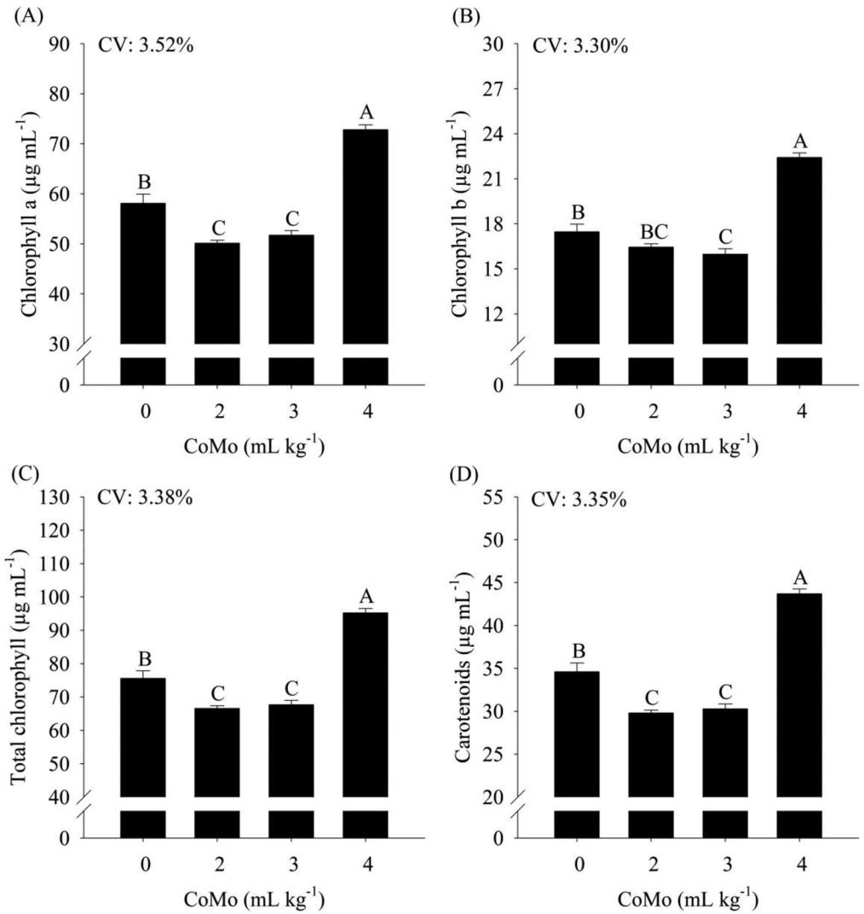

Figure 2. (A) Concentrations of chlorophyll a, (B) chlorophyll b, (C) total chlorophyll, and (D) carotenoids in peanut (Arachis hypogaea) plants as a function of cobalt and molybdenum (CoMo) doses in the seed treatment. CV corresponds to the coefficient

of variation. Letters classify means according to the Tukey test at 5% probability. The bars represent the standard error of the mean (n ¼ 4).

treatments, 2 or 4 mL kg 1, did not differ statistically from each other or from the control. The sucrose fraction concentrations in the leaf tissues did not differ statistically in relation to the treatments (Figure 4A). This result suggested that the increase in total sugar levels in peanut leaves was due to other carbohydrate species.

Ureides

The concentration of the allantoin fraction in plants treated with 2 mL kg 1 CoMo was reduced by 44% compared with the control treatment plants (Figure 5B). Similarly, control plants had a 61% higher allantoin fraction than plants treated with 3 mL kg 1 and a 60% higher fraction than plants treated with 4 mL kg 1.

1914  T. G. GERICÓ ET AL.

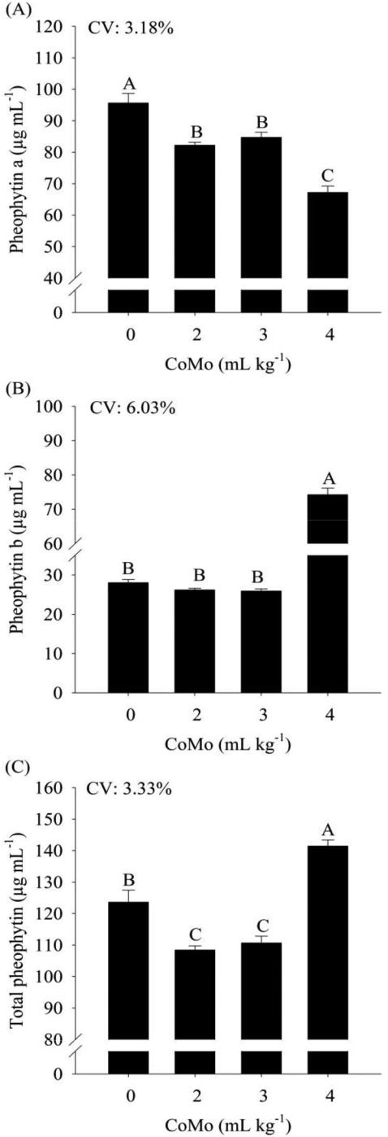

Figure 3. (A) Concentrations of pheophytin a, (B) pheophytin, and (C) total pheophytin in peanut (Arachis hypogaea) plants as a function of cobalt and molybdenum (CoMo) doses in the seed treatment. CV corresponds to the coefficient of variation. Letters classify means according to the Tukey test at 5% probability. The bars represent the standard error of the mean (n ¼ 4).

JOURNAL OF PLANT NUTRITION  1915

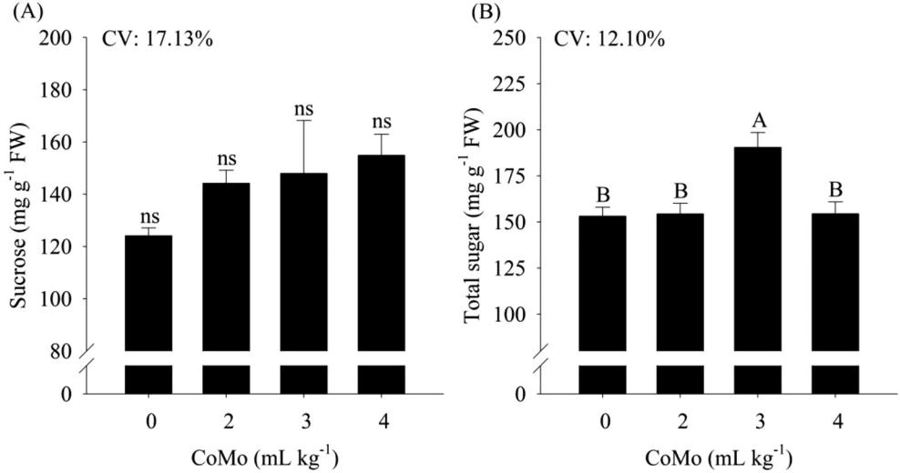

Figure 4. (A) Concentrations of sucrose and (B) total sugar in peanut (Arachis hypogaea) plants as a function of cobalt and molybdenum (CoMo) doses in the seed treatment. CV corresponds to the coefficient of variation. Letters classify means according to the Tukey test at 5% probability. The bars represent the standard error of the mean (n ¼ 4).

The concentrations of total ureides and allantoic acid in peanut leaves did not differ statistic-ally with the application of CoMo (Figure 5A, C). These results indicated a greater influence of allantoic acid on nitrogen compounds in peanut plants because the concentration of total ureides was not significantly influenced by the allantoin fraction.

Ammonia and amino acids

The results obtained for ammonia concentration in leaves indicated a beneficial effect of CoMo applications doses (Figure 6B). This effect was more pronounced at doses of 2 or 3 mL kg 1, which were 37% and 41% higher, respectively, than the control plants. The dose of 4 mL kg-1 also increased leaf ammonium concentration by only 16% compared with the control plants. The dose of 4 mL kg 1 product used also increased the leaf ammonium concentration; however, it was only 16% higher compared with the control treatment plants.

The amino acid levels in peanut leaves were positively influenced by the application of CoMo (Figure 6C). Plants treated with a dose of 4 mL kg 1 showed increases of 86% compared with the control. Likewise, those that received 2 or 3 mL kg 1 CoMo showed increases in amino acid con-centrations of 55 and 42%, respectively.

The effects of CoMo doses on nitrogen metabolism in peanut plants were more evident based on the results of nitrogen compounds (Figure 6D). Plants that were treated with the highest dose of Co and Mo (4 mL kg 1) showed increased in total nitrogen compounds by 68% compared with control plants (Figure 6D). Similarly, doses of 2 or 3 mL kg 1 of the product provided increases of 35% and 28%, respectively, in total nitrogen compounds. The results supported a positive influence of the higher dose of CoMo in the treatment of peanut seeds. This practice provided more efficient plants for the storage and incorporation of the nitrogen forms absorbed by plants. However, no effect was observed for peanut yield ([Supplementary material](https://doi.org/10.1080/01904167.2020.1750646) 1).

Discussion

Seeds treated with CoMo provided peanut plants with higher concentrations of photosynthetic pigments and carotenoids in leaves (Figure 1). Likewise, higher total soluble sugar production

1916  T. G. GERICÓ ET AL.

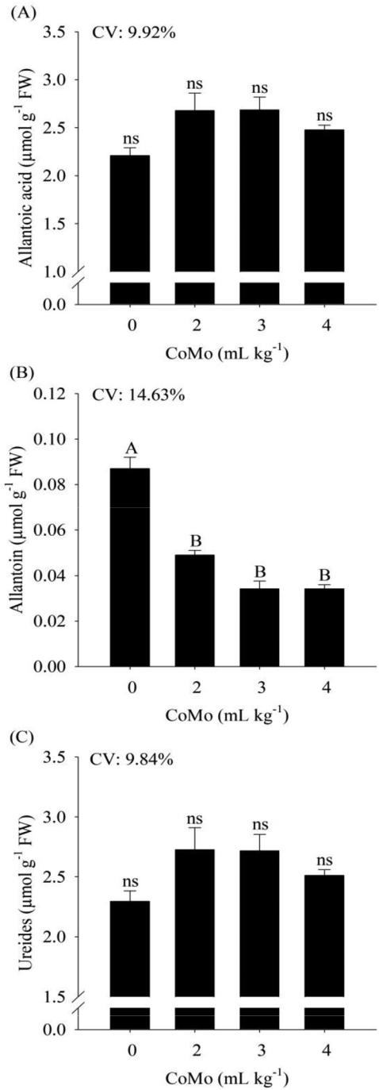

Figure 5. (A) Concentrations of allantoic acid, (B) allantoin, and (C) total ureides in peanut (Arachis hypogaea) plants as a func-tion of cobalt and molybdenum (CoMo) doses in the seed treatment. CV corresponds to the coefficient of variation. Letters clas-sify means according to the Tukey test at 5% probability. The bars represent the standard error of the mean (n ¼ 4).

was observed in these plants (Figure 3). Notably, the accumulation of sugars was not governed by the sucrose fraction (Figure 3A). Other carbohydrate species may contribute to the total produc-tion of reducing sugars such as hexose (glucose and/or fructose) (Amirjani 2011). CO directly

JOURNAL OF PLANT NUTRITION  1917

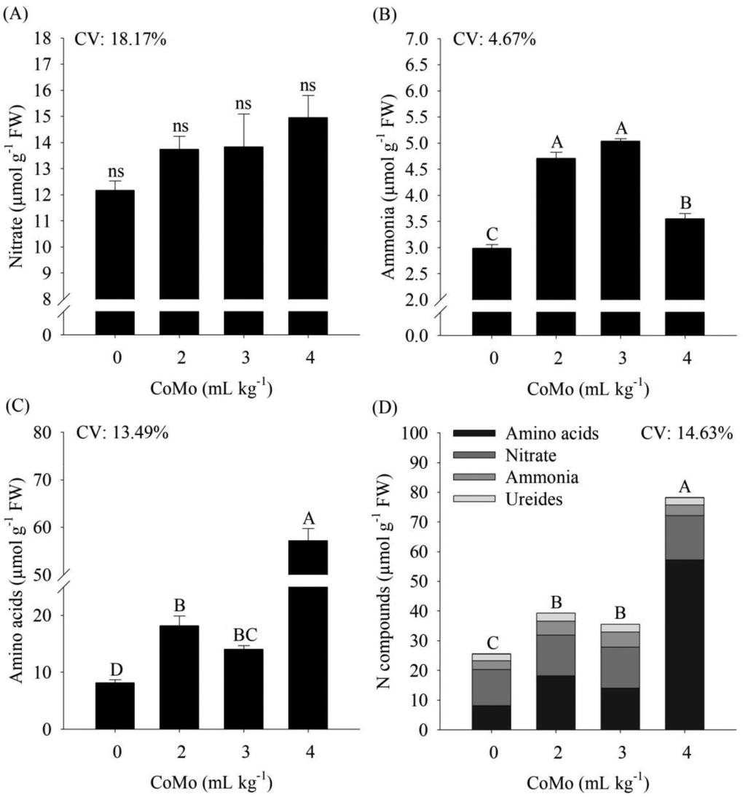

Figure 6. (A) Concentrations of nitrate, (B) ammonium, (C) amino acids, and (D) N compounds in peanut (Arachis hypogaea) plants as a function of cobalt and molybdenum (CoMo) doses in the seed treatment. CV corresponds to the coefficient of vari-ation. Letters classify means according to the Tukey test at 5% probability. The bars represent the standard error of the mean (n ¼ 4).

participates in fatty acid oxidation processes (Gad 2012). The reaction of cobalamin-dependent results in succinyl-CoA, an intermediate compound in the citric acid cycle (Ge et al. 2014). This compound is necessary for the synthesis of tetrapyrrolic nuclei (porphyrins), which are heme coordination complexes that are present in chlorophylls with the specific function of retaining magnesium ions (Mochizuki et al. 2010). In this sense, it is assumed that the increase in the con-centration of photosynthetic pigments in peanut leaves results from the availability/supply of Co in plant tissues, ordered by the CoMo treatments.

Tripathy, Bhatia, and Mohanty (1981), Tripathy, Bhatia, and Mohanty (1983), and El-Sheekh and Hammouda (1992) described the effects of Co on changes in energy distribution and electron excitation in PSII compared to PSI, which contributes to increases in the formation of ATP mole-cules caused by the cyclic flow of electrons in cell chloroplasts.

1918  T. G. GERICÓ ET AL.

The negative effect of the absence of CoMo on plants was observed based on the results of pheophytin a, which was found to be a possible indicator of peanut stress conditions (Figure 2A). Seeds treated with the highest dose of CoMo (4 mL kg 1) resulted in the lowest concentration of pheophytin in leaves, i.e., chlorophyll a complexes without central magnesium ions (Shipman 2012). Although this compound was not predominant in comparison to the total pheophytin accumulation (Figure 2C), pheophytin was negatively correlated with the concentrations of other photosynthetic pigments (chlorophyll a, chlorophyll b, total chlorophyll, and carotenoids) (Figure 7). Of note, strong negative correlations (correlation coefficients below r ¼ 0.70 ) were observed between pheophytin a amino acids and total nitrogen compounds, which was a direct effect of the low efficiency of plant nitrogen metabolism in the absence of Co and Mo (Figure 7).

Regarding the nitrogen metabolism in peanut plants, there was an antagonistic effect of the treatments with CoMo only when the concentration of allantoin was detected in leaves (Figure 4B). There was a reduction in the allantoin concentration following the application of 2, 3, and 4 mL kg 1 CoMo. However, this result cannot be considered a negative effect on the metabolism of nitrogen compounds because the reduction of allantoin was not predominant compared with the total remaining accumulation of ureides, indicating a change in the ureide form present in leaves due to the CoMo treatments (Figure 4C). Depending on the legume species, the fixed nitrogen is exported as amides (glutamine and asparagine) or ureides (allantoin and allantoic acid), which are initially derived from the oxidative degradation of purines (Carter and Tegeder 2016). Allantoin is synthesized in peroxisomes from uric acid, whereas allantoic acid is synthe-sized from allantoin in the endoplasmic reticulum (Lamberto et al. 2010). Even with the CoMo treatments did not increase the concentration of allantoic acid or total ureides in leaves. This behavior was assumed to be due to direct transformation into amino acids, because this was the most abundant compound in peanut plants (Figure 5C, D). This result was confirmed by the negative correlations obtained with allantoin nitrate, ammonia, amino acids, and dried pod yield (Figure 7). In general, it is assumed that the application of CoMo was beneficial for the pro-duction of ureides, and even in the absence of significant differences in relation to the control treatment plants, there was a tendency toward an increase with doses of 2 or 3 mL kg 1 (Figure 4A, C).

No changes were observed in the nitrate concentrations in peanut leaves, but the ammoniacal form was sensitive to the CoMo treatments (Figure 5A, B). The concentrations of leaf ammonia increased when CoMo doses of 2 or 3 mL kg 1 were applied. In contrast, the higher dose of CoMo decreased the ammonia concentration. In this study, ammonia was quickly incorporated into lower-molecular-weight compounds, i.e., amino acids.

External stimuli or stresses, as well as the plant nutritional status, modulate the expression and/or activity of transport systems and enzymes by various regulatory mechanisms. In addition to the influence of Mo on the activity of nitrogenase and nitrate reductase, its participation in the mobilization and export of nitrogen fixed outside the nodules requires the activity of another molybdenum enzyme called xanthine dehydrogenase (Werner and Witte 2011). After this mobil-ization process, ureides are synthesized by the oxidation of purines that are produced in the plastids of the infected cells. Purines are synthesized from glutamine, glycine, aspartate, and ribose-5-phosphate (Boland and Schubert 1982; Boland et al. 1982), which are amino acids and polysaccharides. The first purine to be synthesized is inosine monophosphate, which is oxidized to xanthine monophosphate and exported to non-infected cells, where it is oxidized to uric acid by the enzyme xanthine dehydrogenase (Werner and Witte 2011).

The direct effects of Mo deficiency on xanthine dehydrogenase activity in legume nodules are not fully understood. However, Mo deficiency affects the ability of the plant to export reduced nitrogen from the nodule (Werner and Witte 2011). Symptoms of deficiency may also be masked by the indirect effect of Mo on nitrogen metabolism enzymes (i.e., nitrogenase and nitrate reductase).

JOURNAL OF PLANT NUTRITION  1919

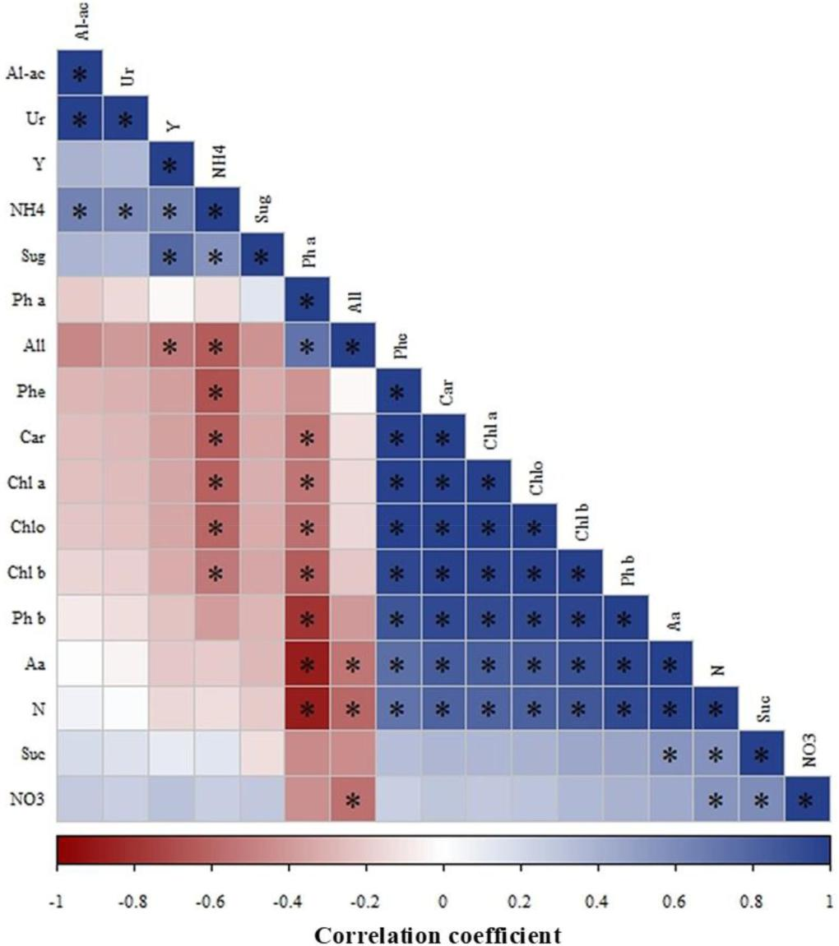

Figure 7. Heatmap of the Pearson correlation coefficients obtained from variables extracted from peanut (Arachis hypogaea) plants. indicates a significant correlation (p < 0.05). Abbreviations: chlorophyll a (Chl a), chlorophyll b (Chl b), total chlorophyll (Chlo), carotenoids (Car), pheophytin a (Ph a), pheophytin b (Ph b), total pheophytin (Phe), sucrose (Suc), total sugar (Sug), allan-toic acid (Al-ac), allantoin (All), total ureides (Ur), nitrate (NO3), ammonia (NH4), amino acids (Aa), total N compounds (N), yield of dried pods (Y).

Seed treatment increased the nitrogen compounds in leaves (Figure 6), however, no effect was observed for peanut yield ([Supplementary material](https://doi.org/10.1080/01904167.2020.1750646) 1). The concentration of amino acids consid-erably increased in plants generated from seeds that received the highest dose of CoMo (Figure 6C). It was also positively correlated with the levels of total soluble sugars and photosyn-thetic pigments (Figure 7). The concentrations of amino acids accounted for the majority of nitrogen compounds, on average 50%, followed by the levels of nitrate (35%), ammonia (11%), allantoic acid (7%), and allantoin (0.2%).

Improving the nitrogen use efficiency of cultivated plants is of fundamental importance for better plant growth and yield. Definitions of efficiency differ depending on whether plants are

1920  T. G. GERICÓ ET AL.

grown to produce biomass or grain yield. However, for most crops, the use of nitrogen mainly depends on how plants extract inorganic nitrogen from the soil, assimilate nitrate and ammonia, and recycle organic nitrogen. The detection of limiting factors that could be manipulated to increase nitrogen use efficiency, such as adequate CoMo fertilization, may be the most appropri-ate alternative to improve productive agricultural systems in the 21st century.

Conclusion

Seed treatment with Co and Mo enhanced leaf pigments such as chlorophylls, carotenoids, and primary metabolism of peanut plants.

The yield of dried pods was not affected by the treatments; however, it was positively corre-lated with the concentrations of ammonia and total soluble sugars and negatively correlated with allantoin.

The dose of 4 mL kg 1 Co and Mo is recommended to increase the nitrogen compounds in peanut plants. Further studies are needed to evaluate the Co and Mo dose-response in other pea-nut genotypes under field conditions to establish the optimal recommendation aiming higher pea-nut yield.

Funding

ARR thanks the Brazilian National Council for Scientific and Technological Development (CNPq) for the research fellowship (Grant number 309380/2017-0).

References

Ali, B., S. Hayat, Q. Hayat, and A. Ahmad. 2010. Cobalt stress affects nitrogen metabolism, photosynthesis and antioxidant system in chickpea (Cicer arietinum L.). Journal of Plant Interactions 5 (3):223–31. doi: [10.1080/](https://doi.org/10.1080/17429140903370584) [17429140903370584](https://doi.org/10.1080/17429140903370584).

Amirjani, M. R. 2011. Effect of salinity stress on growth, sugar content, pigments and enzyme activity of rice.

International Journal of Botany 7 (1):73–81. doi: [10.3923/ijb.2011.73.81](https://doi.org/10.3923/ijb.2011.73.81).

Bieleski, R. L., and N. A. Turner. 1966. Separation and estimation of amino acids in crude plant extracts by thin-layer electrophoresis and chromatography. Analytical Biochemistry 17 (2):278–93. doi: [10.1016/0003-2697(66)90206-5](https://doi.org/10.1016/0003-2697(66)90206-5).

Boland, M. J., J. F. Hanks, P. H. Reynolds, D. G. Blevins, N. E. Tolbert, and K. R. Schubert. 1982. Subcellular organization of ureide biogenesis from glycolytic intermediates and ammonium in nitrogen-fixing soybean nod-ules. Planta 155 (1):45–51. doi: [10.1007/BF00402930](https://doi.org/10.1007/BF00402930).

Boland, M. J., and K. R. Schubert. 1982. Purine biosynthesis and catabolism in soybean root nodules: Incorporation of 14C from 14CO2 into xanthine. Archives of Biochemistry and Biophysics 213 (2):486–91. doi: [10.1016/0003-9861(82)90574-4](https://doi.org/10.1016/0003-9861(82)90574-4).

Brychkova, G., V. Grishkevich, R. Fluhr, and M. Sagi. 2013. An essential role for tomato sulfite oxidase and enzymes of the sulfite network in maintaining leaf sulfite homeostasis. Plant Physiology 161 (1):148–64. doi: [10.](https://doi.org/10.1104/pp.112.208660) [1104/pp.112.208660](https://doi.org/10.1104/pp.112.208660).

Caires, E. F., and C. A. Rosolem. 2000. Nodulac¸~ao e absorc¸~ao de nitrog^enio pelo amendoim em resposta a calagem, cobalto e molibd^enio. Scientia Agricola 57 (2):337–41. doi: [10.1590/S0103-90162000000200022](https://doi.org/10.1590/S0103-90162000000200022).

Carter, A. M., and M. Tegeder. 2016. Increasing nitrogen fixation and seed development in soybean requires com-plex adjustments of nodule nitrogen metabolism and partitioning processes. Current Biology 26 (15):2044–51. doi: [10.1016/j.cub.2016.06.003](https://doi.org/10.1016/j.cub.2016.06.003).

Castro, S., M. Permigiani, M. Vinocur, and A. Fabra. 1999. Nodulation in peanut (Arachis hypogaea L.) roots in the presence of native and inoculated rhizobia strains. Applied Soil Ecology 13 (1):39–44. doi: [10.1016/S0929-1393(99)00016-5](https://doi.org/10.1016/S0929-1393(99)00016-5).

Cataldo, D. A., M. Maroon, L. E. Schrader, and V. L. Youngs. 1975. Rapid colorimetric determination of nitrate in plant tissue by nitration of salicylic acid. Communications in Soil Science and Plant Analysis 6 (1):71–80. doi: [10.1080/00103627509366547](https://doi.org/10.1080/00103627509366547).

JOURNAL OF PLANT NUTRITION  1921

Czerpak, R., A. Bajguz, K. Chodkowski, and H. Popow. 1994. Influence of nickel and cobalt on the growth and biochemical changes of Chlorella pyrenoidosa [Chlorophyceae]. Polskie Archiwum Hydrobiologii 2 (41):161–9.

DuBois, M., K. A. Gilles, J. K. Hamilton, P. A. Rebers, and F. Smith. 1956. Colorimetric method for determination of sugars and related substances. Analytical Chemistry 28 (3):350–6. doi: [10.1021/ac60111a017](https://doi.org/10.1021/ac60111a017).

El-Sheekh, M. M., A. H. El-Naggar, M. E. H. Osman, and E. El-Mazaly. 1992. Effect of cobalt on growth, pigments and the photosynthetic electron transport in Monoraphidium minutum and Nitzchia perminuta. Brazilian Journal of Plant Physiology 15 (3):159–66. doi: [10.1590/S1677-0420000300005](https://doi.org/10.1590/S1677-0420000300005).

Embrapa. 2017. Manual de metodos de analise de solo, 575. Rio de Janeiro: Centro Nacional de Pesquisa de Solos.

Embrapa. 2018. Brazilian soil classification system, 5th ed., 531. Brasılia: Embrapa Solos.

Fukami, J., P. Cerezini, and M. Hungria. 2018. Azospirillum: Benefits that go far beyond biological nitrogen fix-

ation. AMB Express 8 (1):73. doi: [10.1186/s13568-018-0608-1](https://doi.org/10.1186/s13568-018-0608-1).

Gad, N. 2012. Role and importance of cobalt nutrition on groundnut (Arachis hypogaea) production. World Applied Sciences Journal 20 (3):359–67. doi: [10.5829/idosi.wasj.2012.20.03.2819](https://doi.org/10.5829/idosi.wasj.2012.20.03.2819).

Gashti, A. H., M. N. S. Vishekaei, and M. H. Hosseinzadeh. 2012. Effect of potassium and calcium application on yield, yield components and qualitative characteristics of peanut (Arachis hypogaea L.) in Guilan Province. Iran World Applied Sciences Journal 16 (4):540–6.

Ge, F., W. Huang, Z. Chen, C. Zhang, Q. Xiong, C. Bowler, J. Yang, J. Xu, and H. Hu. 2014. Methylcrotonyl-CoA carboxylase regulates triacylglycerol accumulation in the model diatom Phaeodactylum tricornutum. The Plant Cell 26 (4):1681–97. doi: [10.1105/tpc.114.124982](https://doi.org/10.1105/tpc.114.124982).

Gerico, T. G., R. F. R. Tavanti, S. C. Oliveira, A. E. B. A. Lourenzani, J. P. Lima, R. P. Ribeiro, L. C. C. Santos, A. R. Reis. 2019. Bradyrhizobium sp. Enhance ureide metabolismo increasing penuts yield. Archives of Microbiology 202:645–656.

Hesberg, C., R. H€ansch, R. R. Mendel, and F. Bittner. 2004. Tandem orientation of duplicated xanthine dehydro-genase genes from Arabidopsis thaliana differential gene expression and enzyme activities. Journal of Biological Chemistry 279 (14):13547–54. doi: [10.1074/jbc.M312929200](https://doi.org/10.1074/jbc.M312929200).

Hille, R., T. Nishino, and F. Bittner. 2011. Molybdenum enzymes in higher organisms. Coordination Chemistry Reviews 255 (9–10):1179–205. doi: [10.1016/j.ccr.2010.11.034](https://doi.org/10.1016/j.ccr.2010.11.034).

Lamberto, I., R. Percudani, R. Gatti, C. Folli, and S. Petrucco. 2010. Conserved alternative splicing of Arabidopsis transthyretin-like determines protein localization and S-allantoin synthesis in peroxisomes. The Plant Cell 22

(5):1564–74. doi: [10.1105/tpc.109.070102](https://doi.org/10.1105/tpc.109.070102).

Lea, P. J., and B. J. Miflin. 2011. Nitrogen assimilation and its relevance to crop improvement. Nitrogen assimilation and its relevance to crop improvement. In Annual Plant Reviews, Nitrogen Metabolism in Plants in the Post-gen-omic Era, ed. C. H. Foyer and H. Zhang, vol. 42, 1–40. UK: Blackwell Publishing Ltd. doi:[10.1002/](https://doi.org/10.1002/9781119312994) [9781119312994](https://doi.org/10.1002/9781119312994)

McCullough, H. 1967. The determination of ammonia in whole blood by a direct colorimetric method. Clinica Chimica Acta 17 (2):297–304. doi: [10.1016/0009-8981(67)90133-7](https://doi.org/10.1016/0009-8981(67)90133-7).

Mendel, R. R., and R. H€ansch. 2002. Molybdoenzymes and molybdenum cofactor in plants. Journal of Experimental Botany 53 (375):1689–98. doi: [10.1093/jxb/erf038](https://doi.org/10.1093/jxb/erf038).

Mochizuki, N., R. Tanaka, B. Grimm, T. Masuda, M. Moulin, A. G. Smith, A. Tanaka, and M. J. Terry. 2010. The cell biology of tetrapyrroles: A life and death struggle. Trends in Plant Science 15 (9):488–98. doi: [10.1016/j.](https://doi.org/10.1016/j.tplants.2010.05.012) [tplants.2010.05.012](https://doi.org/10.1016/j.tplants.2010.05.012).

Montalbini, P. 1998. Purification and some properties of xanthine dehydrogenase from wheat leaves. Plant Science 134 (1):89–102. doi: [10.1016/S0168-9452(98)00046-6](https://doi.org/10.1016/S0168-9452(98)00046-6).

Moretti, L. G., E. Lazarini, J. W. Bossolani, T. L. Parente, S. Caioni, R. S. Araujo, and M. Hungria. 2018. Can add-itional inoculations increase soybean nodulation and grain yield? Agronomy Journal 110 (2):715–21. doi: [10.](https://doi.org/10.2134/agronj2017.09.0540) [2134/agronj2017.09.0540](https://doi.org/10.2134/agronj2017.09.0540).

Nishiyama, R., Y. Watanabe, Y. Fujita, D. T. Le, M. Kojima, T. Werner, R. Vankova, K. Yamaguchi-Shinozaki, K. Shinozaki, T. Kakimoto, et al. 2011. Analysis of cytokinin mutants and regulation of cytokinin metabolic genes reveals important regulatory roles of cytokinins in drought, salt and abscisic acid responses, and abscisic acid biosynthesis. The Plant Cell 23 (6):2169–83. doi: [10.1105/tpc.111.087395](https://doi.org/10.1105/tpc.111.087395).

Quaggio, J. A., P. B. Gallo, C. Owino-Gerroh, M. F. Abreu, and H. Cantarella. 2004. Peanut response to lime and molybdenum application in low pH soils. Revista Brasileira de Ci^encia Do Solo 28 (4):659–64. doi: [10.1590/](https://doi.org/10.1590/S0100-06832004000400008) [S0100-06832004000400008](https://doi.org/10.1590/S0100-06832004000400008).

Pawar, P. B., J. P. Khadilkar, M. V. Kulkarni, and J. S. Melo. 2018. An approach to enhance nutritive quality of groundnut (Arachis hypogaea L.) seed oil through endo mycorrhizal fertigation. Biocatalysis and Agricultural Biotechnology 14:18–22. doi: [10.1016/j.bcab.2018.01.012](https://doi.org/10.1016/j.bcab.2018.01.012).

R Development Core Team. 2015. A language and environment for statistical computing. Vienna, Austria: R Foundation for Statistical Computing. <http://www.R-project.org/>

Rosolem, C. A., and E. F. Caires. 1998. Yield and nitrogen uptake of peanuts as affected by lime, cobalt, and molybdenum. Journal of Plant Nutrition 21 (5):827–35. doi: [10.1080/01904169809365446](https://doi.org/10.1080/01904169809365446).

1922  T. G. GERICÓ ET AL.

Schwarz, G., and R. R. Mendel. 2006. Molybdenum cofactor biosynthesis and molybdenum enzymes. Annual Review of Plant Biology 57 (1):623–47. doi: [10.1146/annurev.arplant.57.032905.105437](https://doi.org/10.1146/annurev.arplant.57.032905.105437).

Shapiro, S. S., and M. B. Wilk. 1965. An analysis of variance test for normality (complete samples). Biometrika 52 (3–4):591–611. doi: [10.2307/2333709](https://doi.org/10.2307/2333709).

Shipman, L. L. 2012. Electronic structure and function of chlorophylls and their pheophytins. In Photosynthesis, ed.

Govindjee, vol. 1, 275–291. Energy Conversion by Plants and Bacteria 799.

Shiv Raj, A. 1987. Cobalt nutrition of pigeon-pea and peanut in relation to growth and yield. Journal of Plant Nutrition 10:2137–45.

Soil Survey Staff. 2014. Keys to soil taxonomy, 12th ed., 360. Washington, DC: United States Department of Agriculture.

Tripathy, B. C., B. Bhatia, and P. Mohanty. 1981. Inactivation of chloroplast photosynthetic electron-transport activity by Ni2þ. Biochimica et Biophysica Acta (BBA) - Bioenergetics 638 (2):217–24. doi: [10.1016/0005-2728(81)90230-9](https://doi.org/10.1016/0005-2728(81)90230-9).

Tripathy, B. C., B. Bhatia, and P. Mohanty. 1983. Cobalt ions inhibit electron-transport activity of photosystem II without affecting photosystem I. Biochimica et Biophysica Acta (BBA) - Bioenergetics 722 (1):88–93. doi: [10.](https://doi.org/10.1016/0005-2728(83)90160-3) [1016/0005-2728(83)90160-3](https://doi.org/10.1016/0005-2728(83)90160-3).

Van Handel, E. 1967. Determination of fructose and fructose-yielding carbohydrates with cold anthrone. Analytical Biochemistry 19 (1):193–4. doi: [10.1016/0003-2697(67)90152-2](https://doi.org/10.1016/0003-2697(67)90152-2).

Van Raij, B., H. Cantarela, J. A. Quaggio, and A. M. C. Furlani. 1996. Recomendac¸~ao de adubac¸~ao e calagem para o estado de S~ao Paulo, 285 p. Campinas: Instituto Agron^omico & Fundac¸~ao IAC.

Vogels, G. D., and C. Van der Drift. 1970. Differential analyses of glyoxylate derivatives. Analytical Biochemistry 33

(1):143–57. doi: [10.1016/0003-2697(70)90448-3](https://doi.org/10.1016/0003-2697(70)90448-3).

Werner, A. K., and C. P. Witte. 2011. The biochemistry of nitrogen mobilization: Purine ring catabolism. Trends

in Plant Science 16 (7):381–7. doi: [10.1016/j.tplants.2011.03.012](https://doi.org/10.1016/j.tplants.2011.03.012).

Williams, R. J. P., and J. F. Da Silva. 2002. The involvement of molybdenum in life. Biochemical and Biophysical Research Communications 292 (2):293–9. doi: [10.1006/bbrc.2002.6518](https://doi.org/10.1006/bbrc.2002.6518).

Yemm, E. W., E. C. Cocking, and R. E. Ricketts. 1955. The determination of amino-acids with ninhydrin. The Analyst 80 (948):209–14. doi: [10.1039/an9558000209](https://doi.org/10.1039/an9558000209).

Yesbergenova, Z., G. Yang, E. Oron, D. Soffer, R. Fluhr, and M. Sagi. 2005. The plant Mo hydroxylases aldehyde oxidase and xanthine dehydrogenase have distinct reactive oxygen species signatures and are induced by drought and abscisic acid. The Plant Journal 42 (6):862–76. doi: [10.1111/j.1365-313X.2005.02422.x](https://doi.org/10.1111/j.1365-313X.2005.02422.x).

Yoshida, S. 1998. Rhizobial production of Vitamin B12 active substances and their localization in some leguminous plants. Japanese Journal of Soil Science and Plant Nutrition 69 (5):435–44.